***Introduction:***

About the Company.

OceanGate Limited is a company established 3 years back which deals in various data storage products right from floppy disk to optical storage devices. It has state of the Art machinery for production of the storage devices/disks which are becoming popular as days pass by due to the excellent quality, fast delivery on purchases and efficient after sales Services.

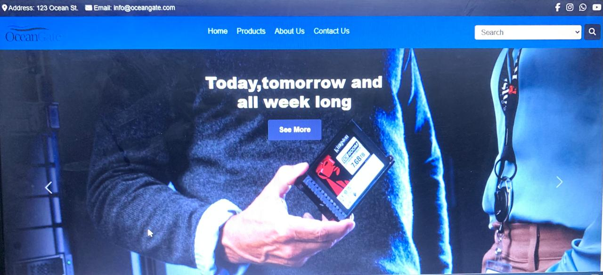Oceangate products have become so popular that the demand for the products is not only coming from local market but also international market.

***TABLE OF CONTENT***

Site Map…………………………………..03

Home…………………………………..04

Brands……..…………………...…….. 05

Products…………………..….. 08

Comparison..………...……….. 09

Contacts..…………..……………….... 10

About………………...………...………11

***SITE MAP:***

***Home***

***ABOUT US:***

The link**MORE ABOUT US** brings you on the page of **ABOUT.**

***SERVICES OVER VIEW:***

When you bring cursor over icons of cars in services overview they flip and when you click on those links They will bring you on the page of products. When you click on the icon of **Brands** it will bring you on the page of **All Brands** and when you click on **Items** icon it will bring you on the page of **Items Details** and like those icons these functions are applicable on other two icons.

***MAIL TO:***

In footer there is another link of mailing. When you click on this link outlook opens in a popup window.This link is available on every page of site.

***BRANDS:***



***TAKE A LOOK:***

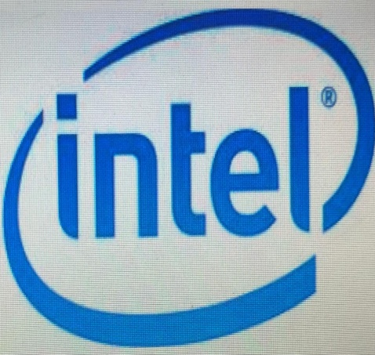**The brands page where you can search products of your favorite brand by clicking a button on it named “Take a Look”.**

***Products:***

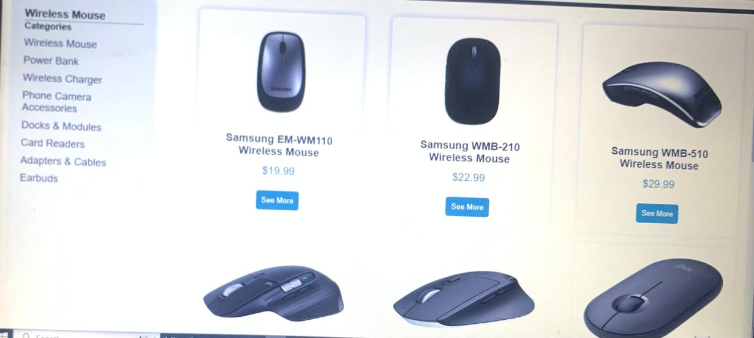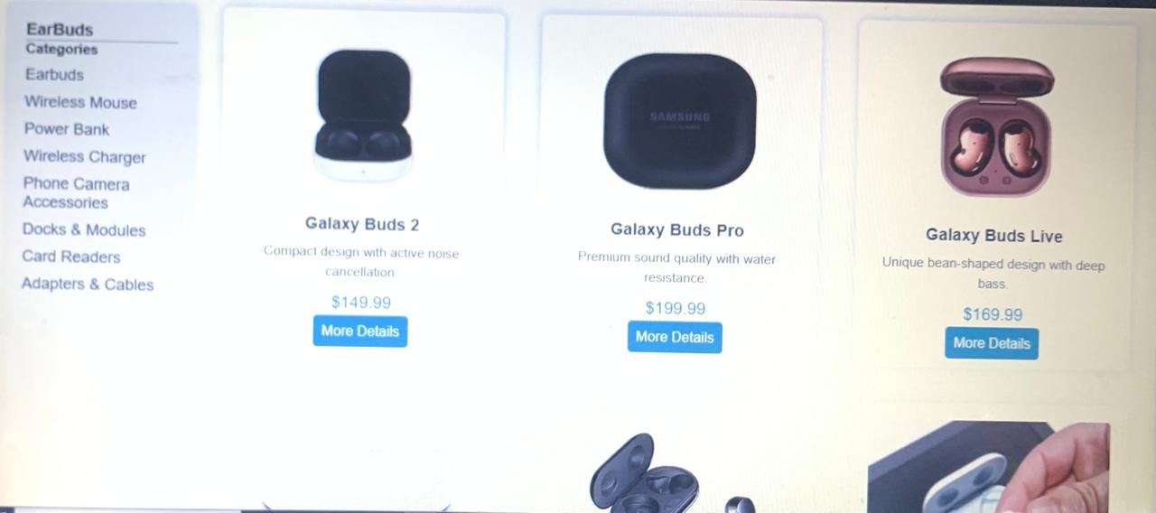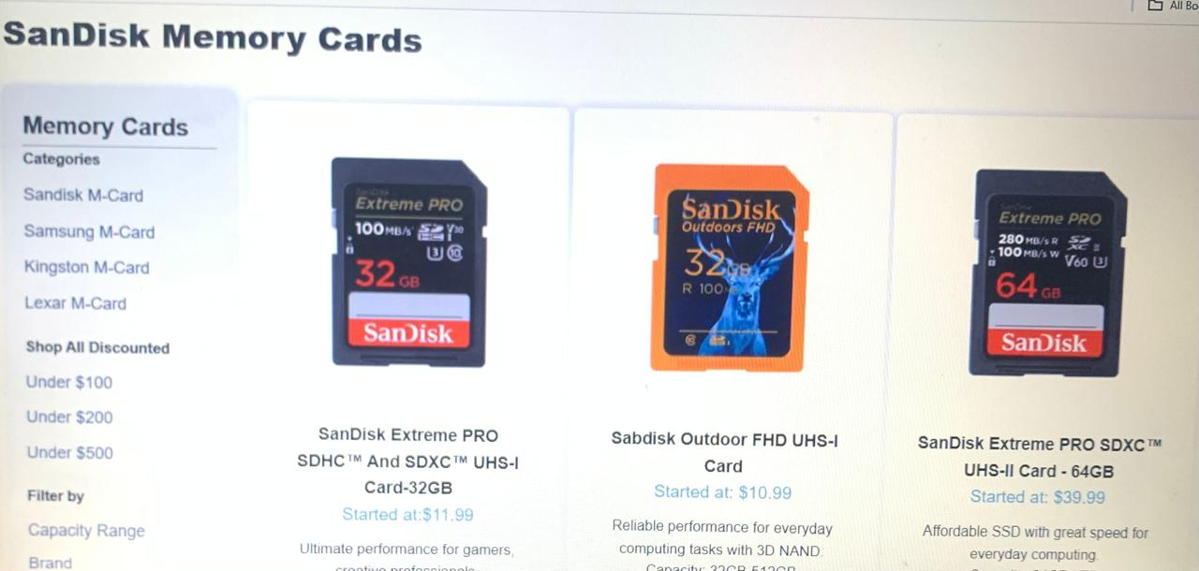**SSD, USB drives, and memory cards are portable storage devices designed for fast and reliable data transfer.You can see all of the products and other accessories by clicking on the button on it.**

***PRODUCTS:***

**Products:**

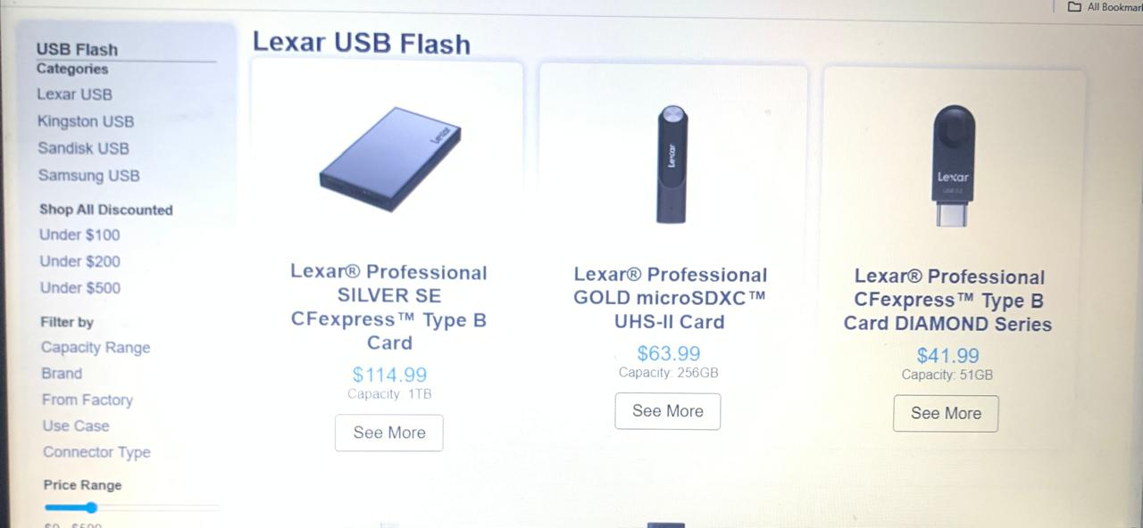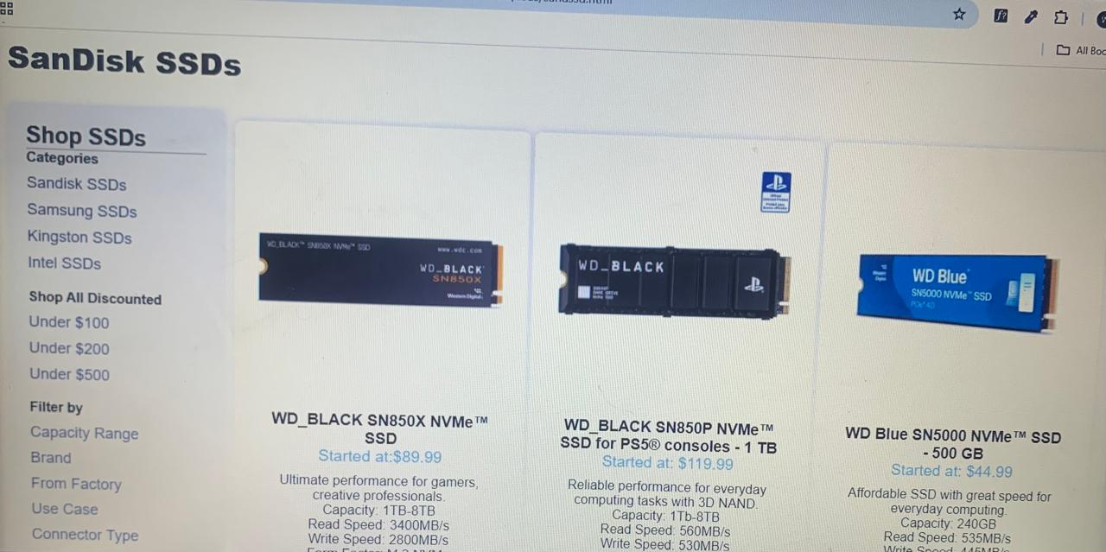Ocean Gate offers a diverse range of high-quality storage solutions, including **SSDs**, **Memory Cards**, and **USB Flash Drives**, each designed to meet varying needs for performance and portability. Their **SSDs** provide fast, reliable storage for demanding tasks like gaming, video editing, and data-intensive applications, with options ranging from internal to external models. **Memory Cards** deliver compact and high-speed storage ideal for cameras, smartphones, and gaming devices, available in microSD, SD, and other formats. **USB Flash Drives** offer convenient, portable storage for everyday use, with various capacities and speeds, making them perfect for transferring files between devices. Each product is engineered for durability, speed, and ease of use, catering to both casual users and professionals alike.

***Comparison:***

***Comparison:***

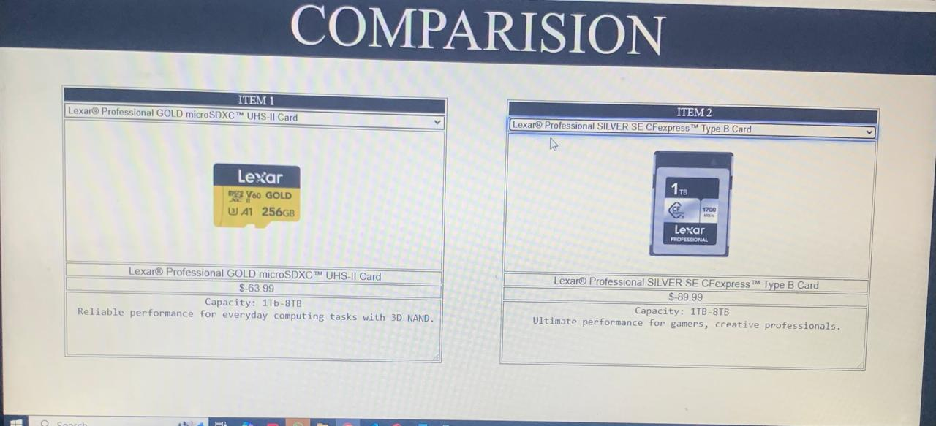The **Comparison Page** on the Ocean Gate website offers a side-by-side comparison of SSDs, USB Flash Drives, and Memory Cards to help customers easily evaluate their options based on key factors like performance, storage capacity, speed, and intended use. Whether you're looking for high-speed storage for a gaming PC, a portable solution for file transfers, or a durable memory card for your camera, this comparison tool simplifies the decision-making process by highlighting the strengths and differences of each product category, making it easier to choose the best solution for your specific needs.

***CONTACT:***

***CONTACT US FORM:***

On this page there is a form of Contact us where you can fill it and can contact us.

***E-MAIL:***

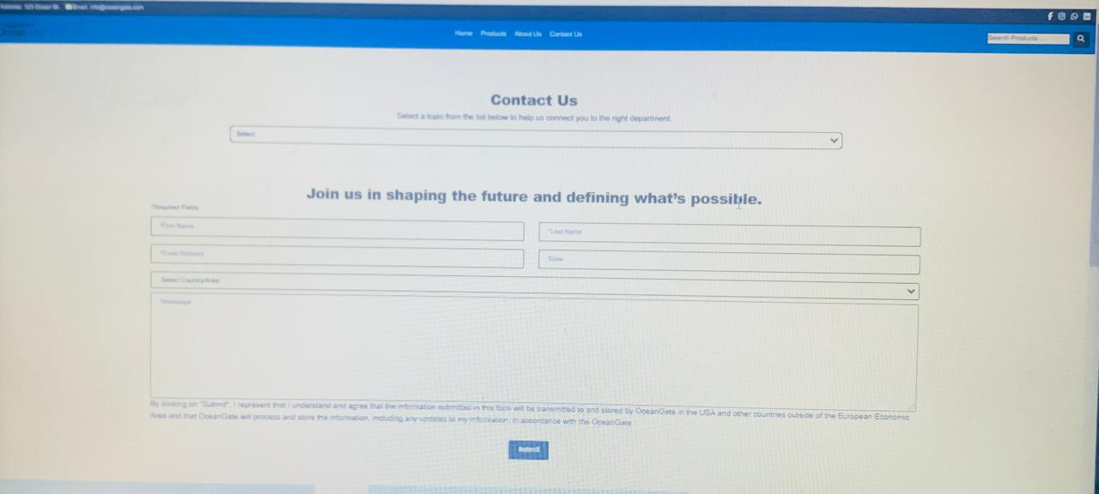On the right side of the page there is a mailing link.When you click on this link outlook opens in a popup window. This link is available on every page of site.

***About Us:***

The About us page is the page where you can easily know about us that what the main information and tactics of our project and website. You can also watch here our team. We also listed here the comments of our clients. We also gave here our standards in bullets.

